**Equipment**

1. Main PC – runs zoom control, mute audio in Zoom. Mute speakers. If you stop video, will show Rotary wheel.
2. Podium PC – for speaker, Mute audio in Zoom. Mute speakers.
3. Canon video camera – on tripod, set to capture in-room video.
4. HDMI gray cable (large HDMI plug at one end, small HDMI plug at one end) for video camera
5. HD video capture plug with USB converter
6. Wireless microphones – 2 (1 for podium, 1 for in-person participation)
7. Audio mixer (Harbinger brand), be sure to plug it in!
8. Cable A (Y-cord, 1 end splits into 2), red
9. Cable B, red
10. Cable C, black, to connect audio mixer to room audio XLR plug
11. HDMI black cable (3 6-ft lengths connected) for projector
12. Epson projector

**Reference:**

Zoom account (only for main PC) [zoom@](mailto:zoom@northbrookrotary.org) ,

password

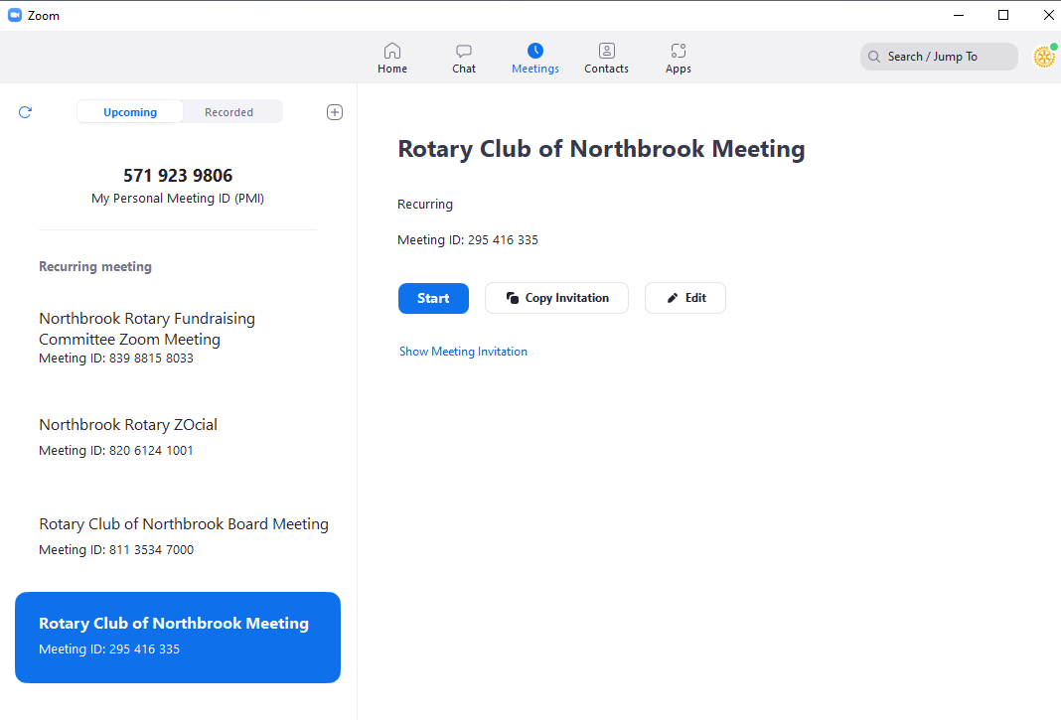

Zoom meeting info (for Podium PC, cell phone, and all remote participants)

Meeting ID **295416335** Passcode **Rotary1965**

**Charging:**

Wireless mic plug needs to be charged before every meeting using USB charging cable.

Canon video camera needs to be charged before every meeting. Charging cable is in the camera box.

Wireless microphones use AA batteries. Spare AA batteries are in equipment suitcase.

**Hilton Wifi:**

SSID = **ATTWIFI** or **HHONORS**)

Option for “coupon or promotion code”

Code for August 2021 = **feelinggood2**

(will change every month – need to ask Sara or Kellie)

**Connections for Audio mixer and Main PC**

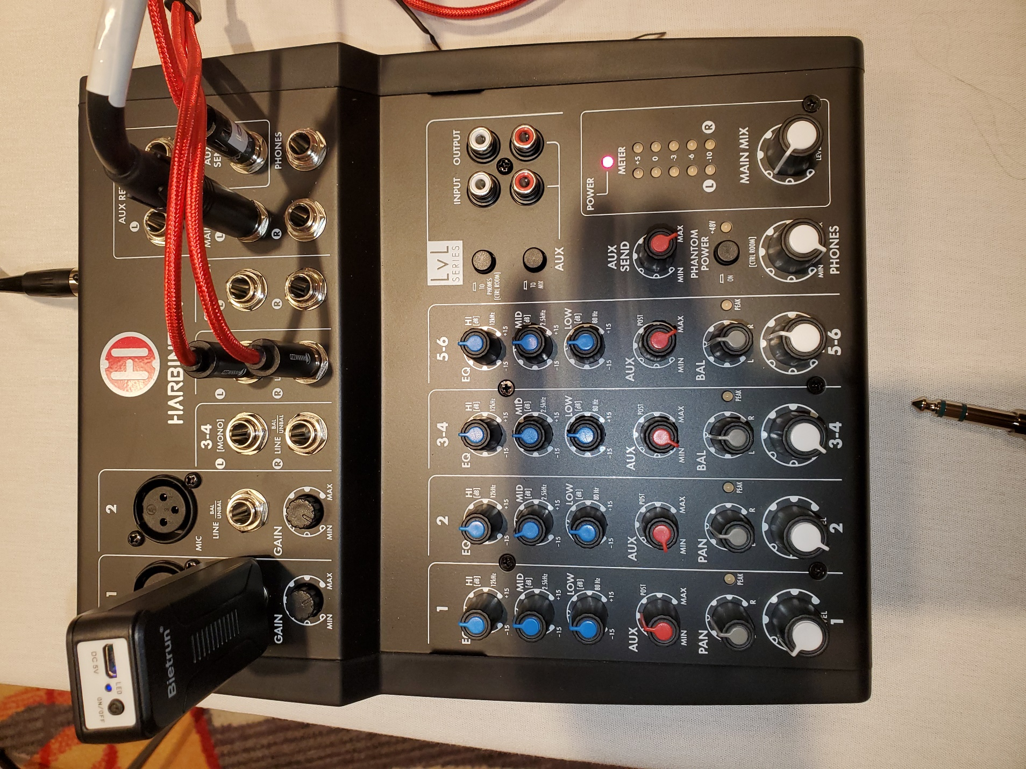

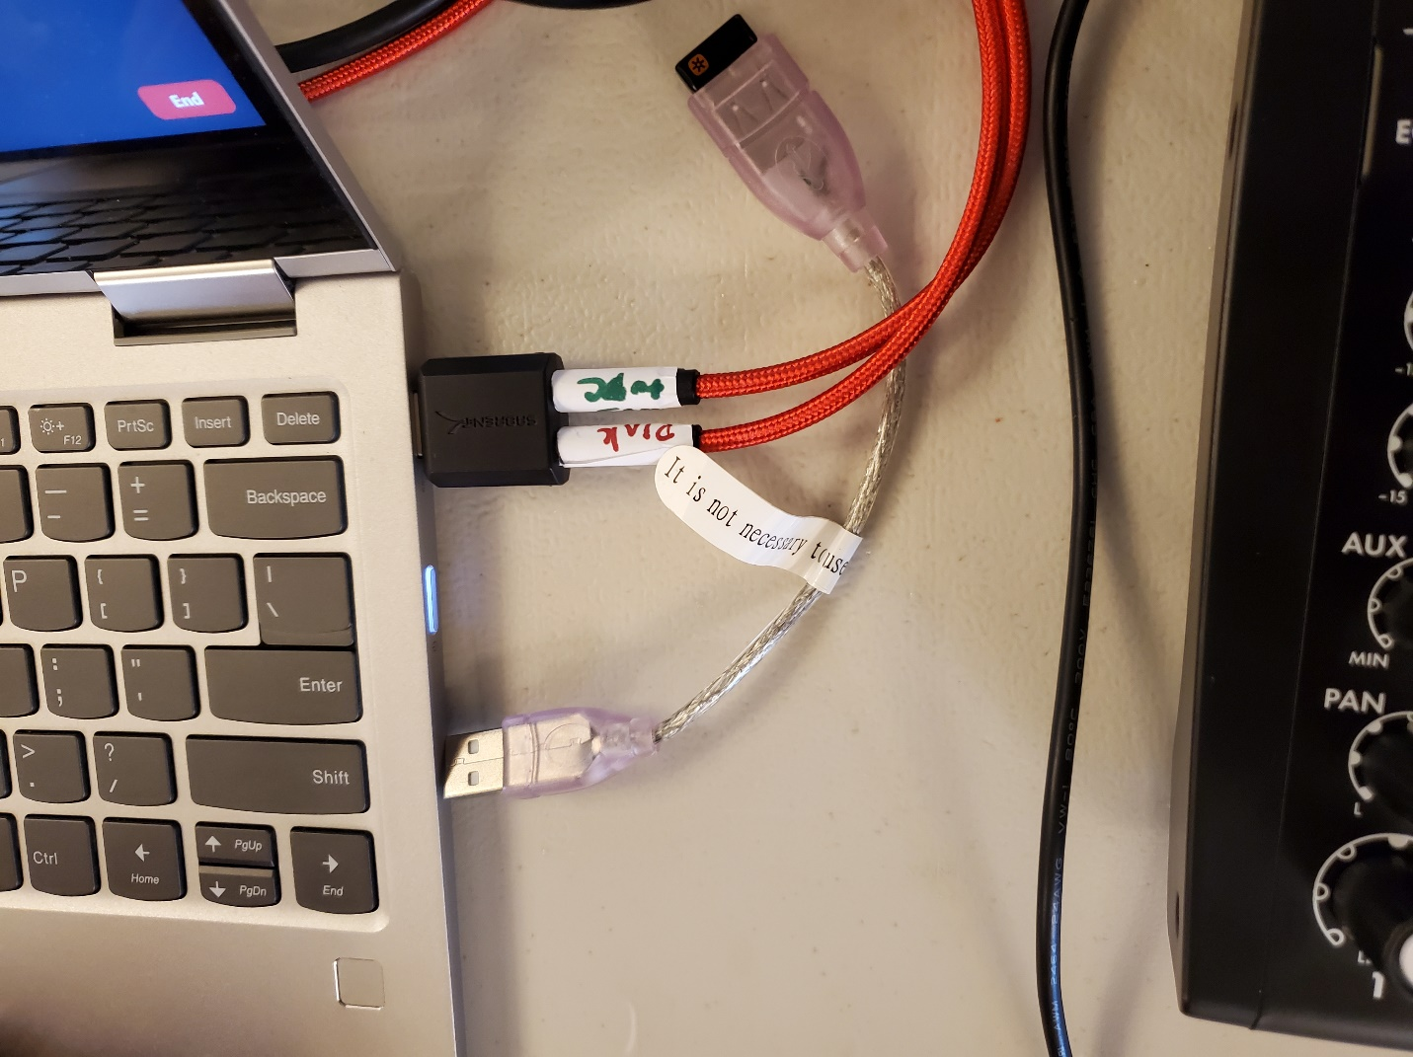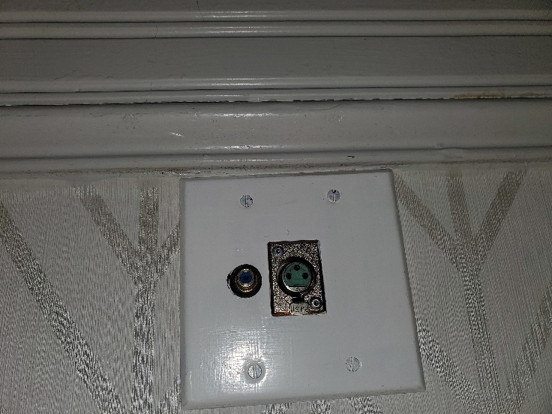

This is USB 2 plug adapter. Plug on left is room audio XLR plug see #8

1. Find USB 2 plug adapter and plug into USB port on Main PC.
2. Insert the single end of cable A to the A plug on USB 2 plug adapter.
3. Insert a single end of cable B to the B plug on USB 2 plug adapter.
4. Cable A splits into 2 cables, plug these into 5 & 6 on the mixer (either order).
5. Cable B other end plug into Mixer Aux Send plug on the mixer.
6. Bietran wireless microphone receiver big plug into Mic 1 input on mixer.
7. HDMI cable from Main PC to Epson projector.
8. Cable C from main output, left (see blue cable in photo above) to room audio XLR plug
9. Mount Canon video camera on tripod (extend the tripod to maximum).
10. Open Canon video camera side screen. Ignore warning about no memory stick.
11. Open Canon video camera lens cover (slide switch near lens).
12. Find gray HDMI cable. Plug small HDMI plug into Canon video camera.  
    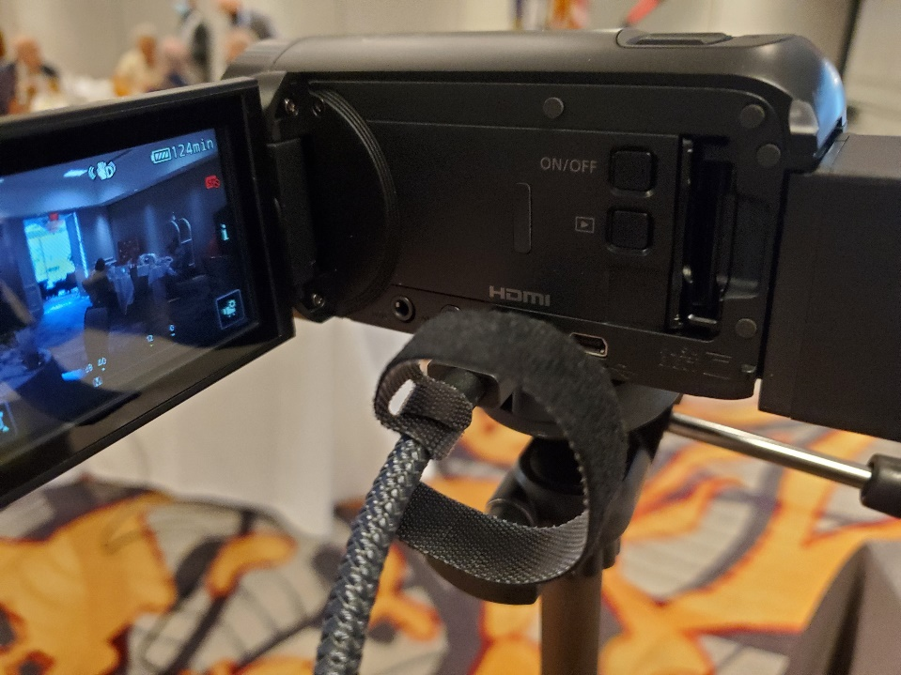
13. Large HDMI plug on gray cable connect to HD video capture device.
14. Connect HD video capture device to USB plug converter (takes standard USB plug to USB-C) and connect to USB-C port on Host PC.

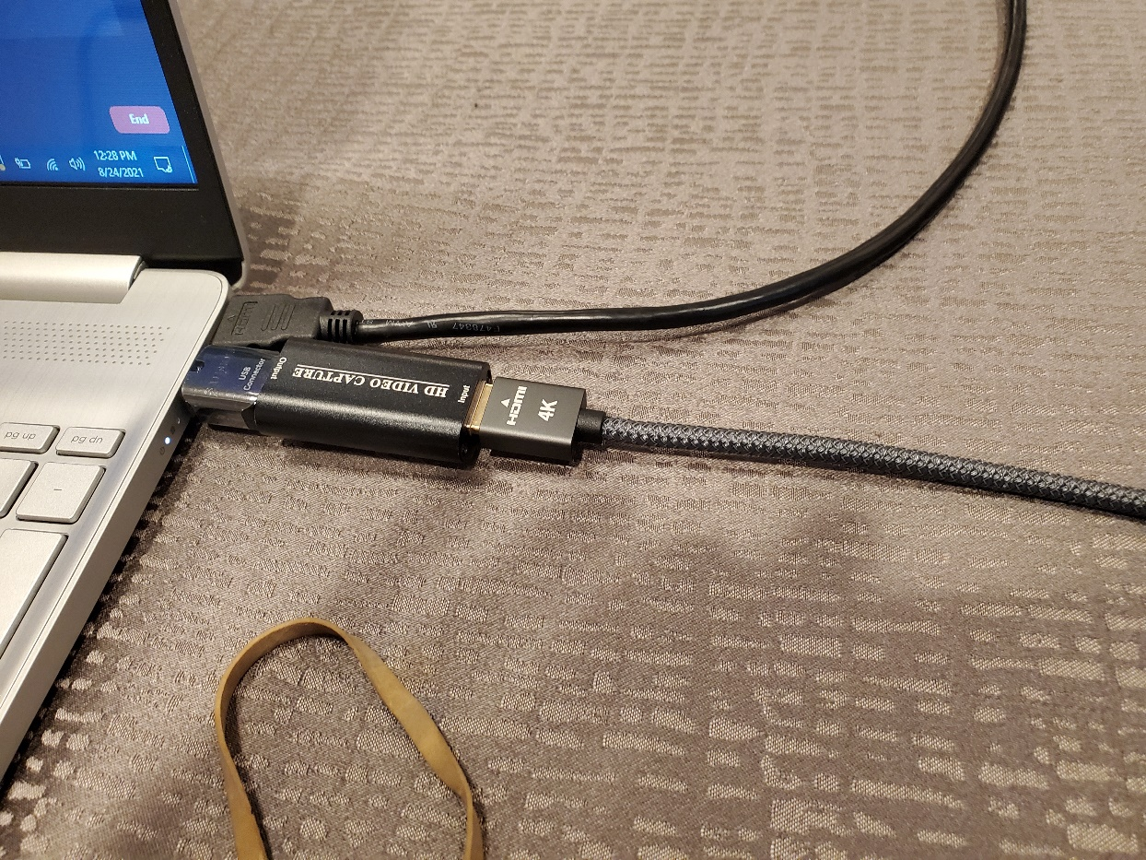

1. In Zoom on Host PC, Video control on toolbar, select USB video.  
   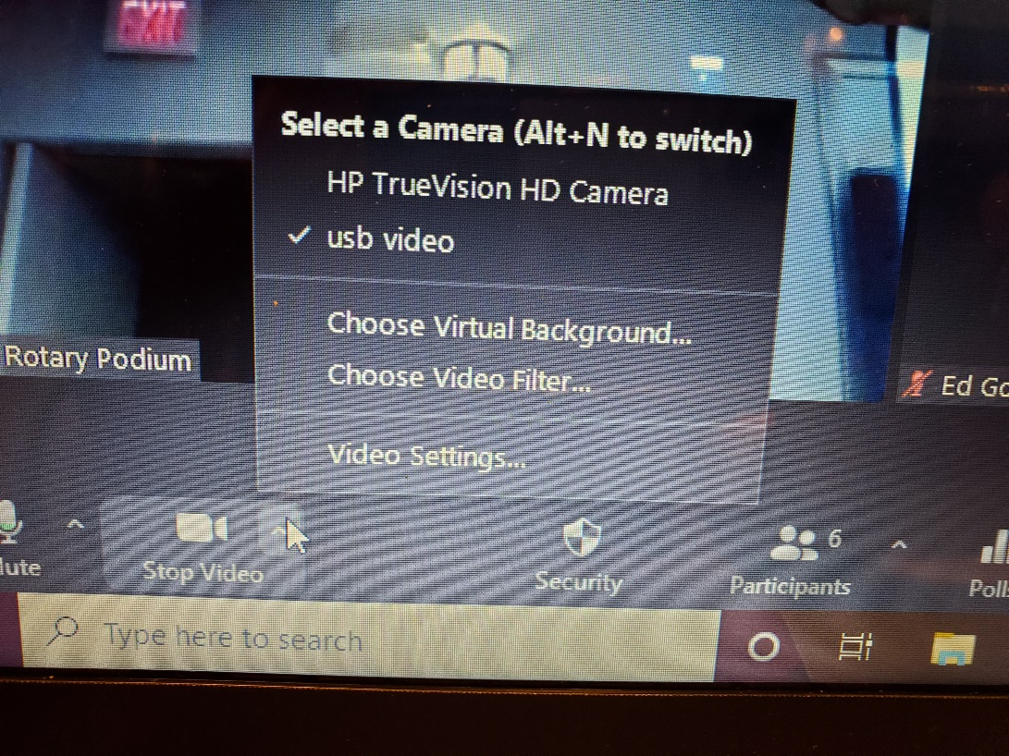
2. Note positions of volume controls.
   1. Mic 1 controls both wireless mics. Volume at around 10 o’clock. Other controls at 12 o’clock.
   2. Zoom audio 5-6 a little past 12 o’clock. Aux set to maximum
   3. Aux send set to maximum.
   4. Main mix at about 10 o’clock.
   5. Room audio setting to -9.0 dB (adjust UP or DOWN)  
      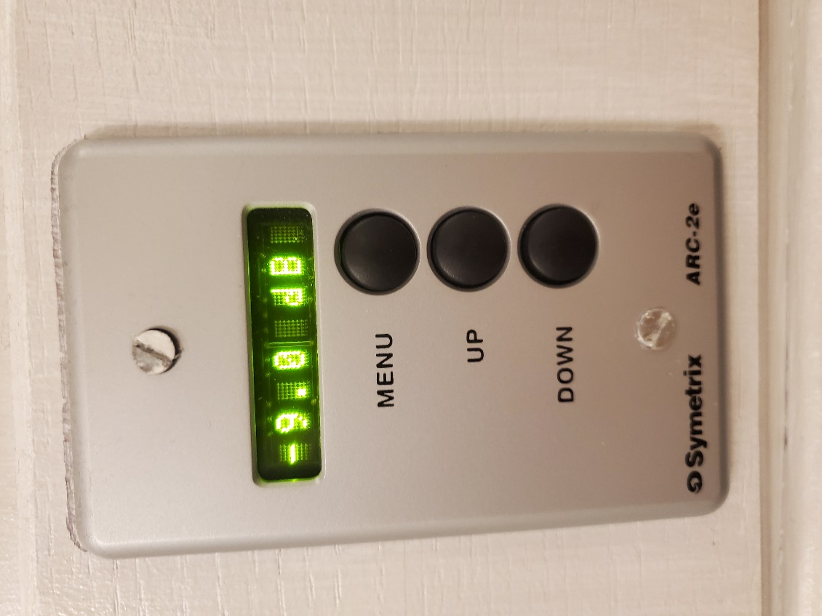

**Podium PC**

Open Zoom app, join meeting for meeting ID **295416335**, passcode **Rotary1965.**

Start Zoom in gallery mode so podium can show all Zoom participants.

**Host PC**

Start Zoom in gallery mode so projected image on screen shows all Zoom participants.

**Attachments and Sharing**

PowerPoints, videos, graphics can be shared from Host PC or Podium PC.

**For in-person presenters:**

Screen sharing in Zoom is enabled. This will permit Zoom attendees to see (and hear) the presentation and also display on the screen in the room with room audio.

**Use the Host PC**

Presentation (PowerPoint, PDF, and/or video file) should be on a USB stick. In advance of the meeting, open the file (corresponding software should automatically load, i.e. PowerPoint, Adobe Acrobat Reader, Windows Media Player). Leave that Window “open” behind Zoom on the Host PC.

When it is time to initiate the presentation, select “Share Screen” at the bottom of the Zoom controls.

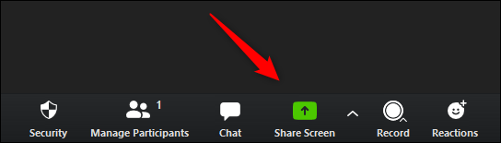

You will see this window open in Zoom. Be sure to click on “**Share computer sound**”, then select the window showing your presentation, and click **Share**.

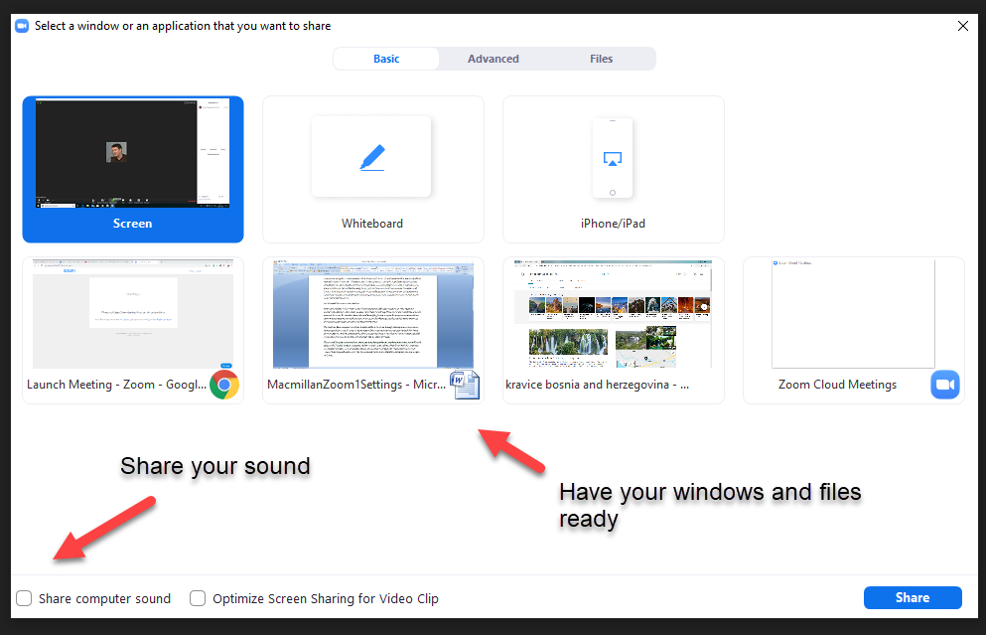

At the end of the presentation, select **Stop Share**.

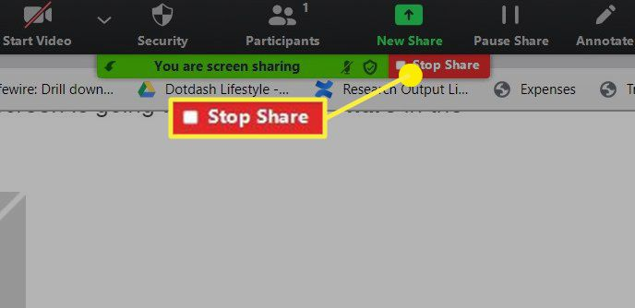

**For remote presenters:**

If presenters are on Zoom, when they start, Spotlight them so that they stay in the center of the screen for all participants. Zoom participants will see them in the center of their screen and in-person participants will see them on the projected Zoom image. If there are multiple remote presenters, you can Spotlight more than one.

Spotlight is preferable to Speaker View or Pinning because it puts the Spotlighted presenter in the center of all screens.

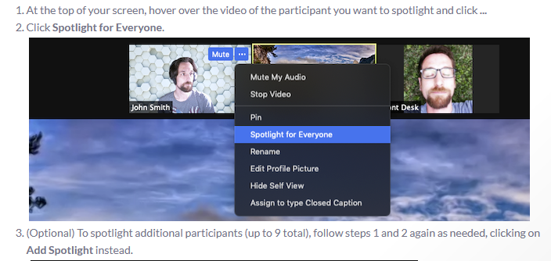

When the presenter(s) is/are finished, Remove Spotlight.



