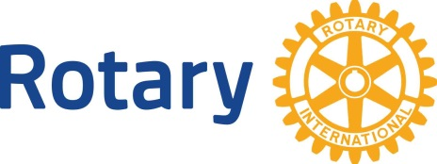
Rotary International

Date No. 10 The Rotary Foundation

Dear (First name):

The Rotary Foundation is the charitable arm of Rotary International, which enables us to significantly impact the world through our humanitarian work. The Rotary Foundation, funded primarily by Rotarians, makes grants possible for local community and international global projects.

The mission of The Rotary Foundation is “To Do Good in the World”. Please consider making a contribution to The Rotary Foundation each and every year. This is easily accomplished through the establishment of a “Rotary Direct” contribution on your My Rotary account. Your contributions accumulate from year to year. When your contributions total $1,000, you will become a Paul Harris Fellow, named after the founder of Rotary. In Rotary, this is one of the highest recognitions you can receive.

Through Rotary, you are part of something larger than yourself. Our combined efforts leverage the talent, time and resources each of us bring to our Rotary membership to help make a difference in our Community and the world. In addition to your active participation in support of our club fundraising efforts to fund local projects, the financial support that you give to The Rotary Foundation is very important.

Contributions to The Rotary Foundation make substantial changes in the world through our combined efforts…like our fight to end Polio in the world and supporting our 6 areas of focus— peace, disease prevention and treatment, water and sanitation, maternal and child health, basic education and literacy and economic and community development.

I am proud to be a Rotarian. I hope you are too!

Yours in Rotary Service,

