2025-26
Document 6
One Summit Toolkit Contents

Toolkit Cover
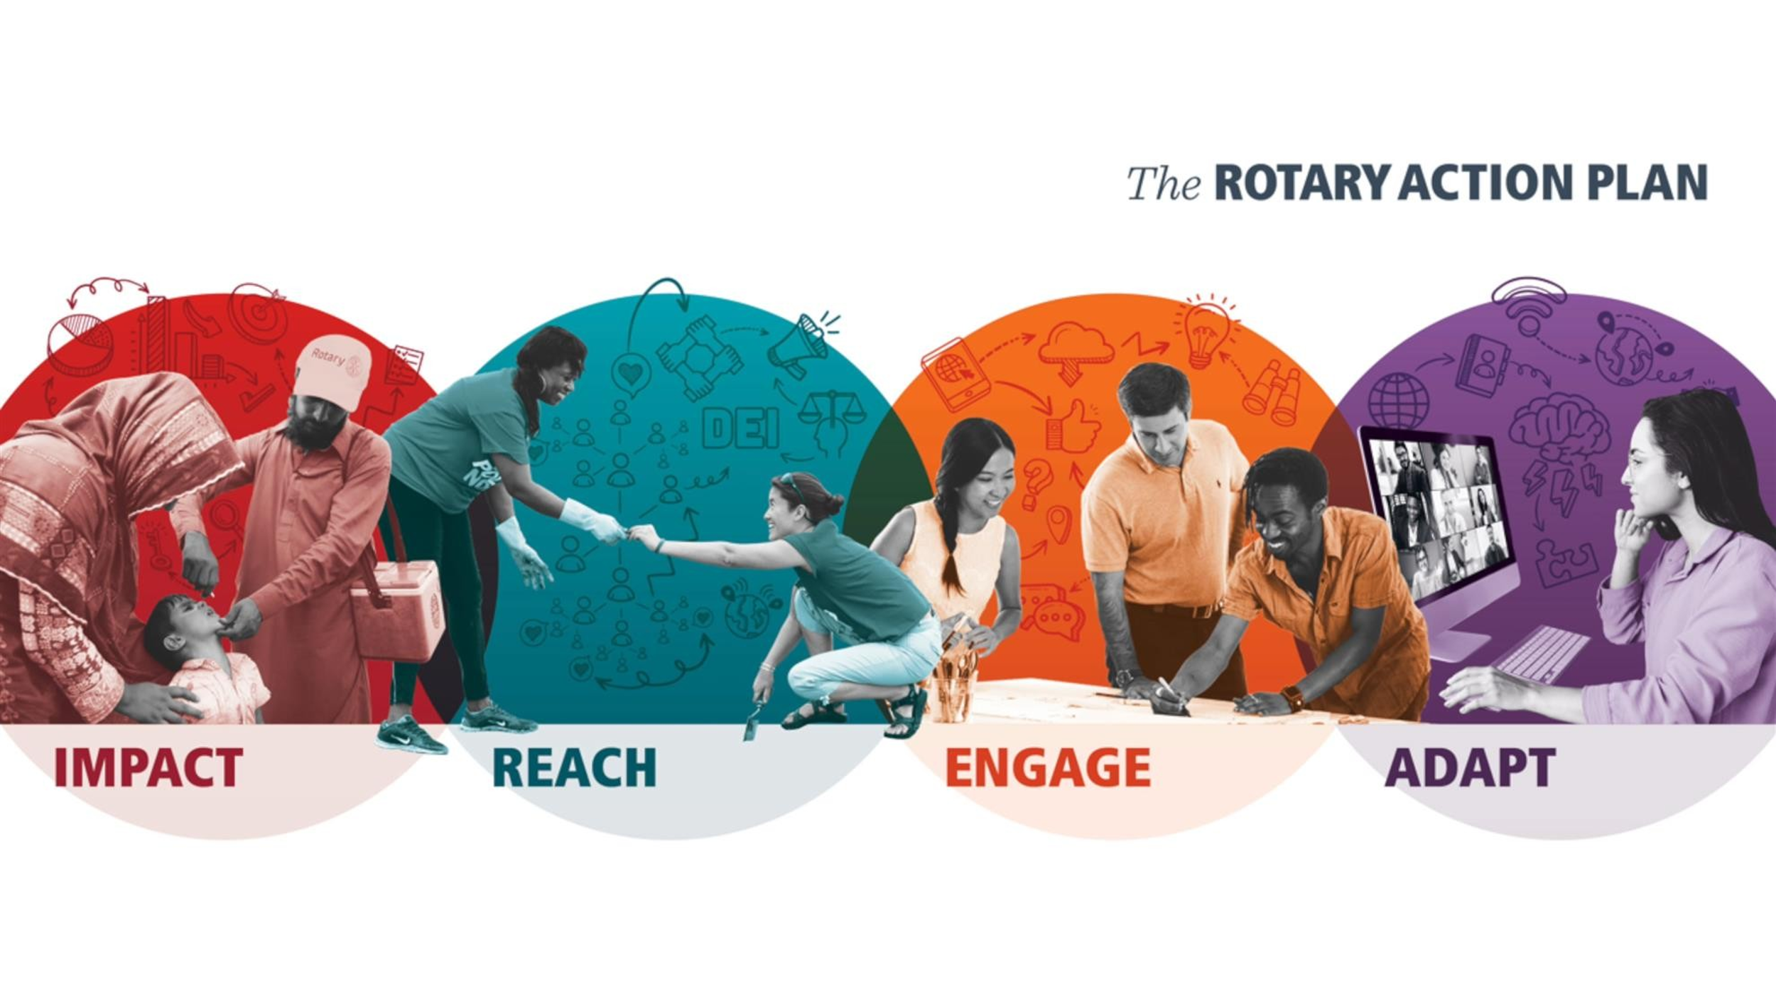
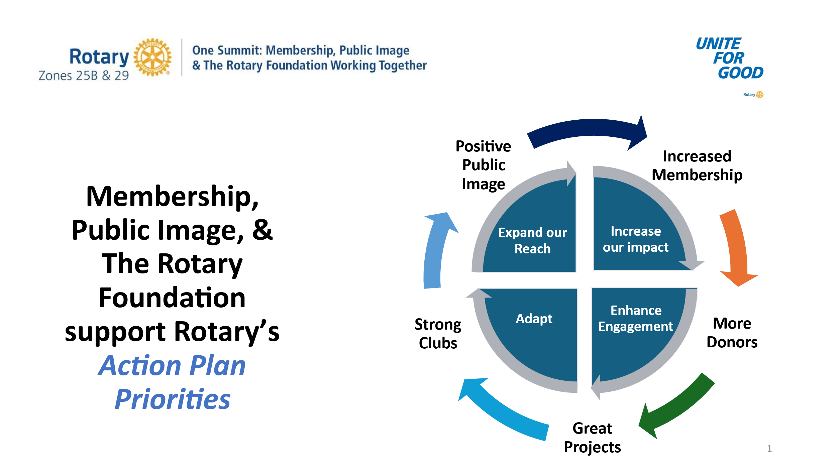
Contents
- My One Summit Takeaways form
- Rotary’s Action Plan: https://tinyurl.com/ClubActionPlan
- Chart of Club Types: https://tinyurl.com/ClubTypes

- Hyperlink for Welcome video https://vimeo.com/1093549248
- Document 6e is a PDF copy of the Bringing the Rotary Action Plan and Membership Growth to Life in Your Club slide set. To access a PowerPoint version of that slide set, click here https://tinyurl.com/RIActionPlanPPT.
- The One Rotary Approach – Find the Synergy
- District Information
- Hyperlink for optional video re: Telling the Story Throughout Every Stage of a Project

