* One Week. One Focus: Rotary Showcase Week
* Showcase your Rotary Club’s projects to your members & news media
* For District & Global Grant projects provide the amount of The Rotary Foundation Grant(s)
* Rotary Showcase Week
* Praesent visl nitxer.

February 16 – 22, 2020

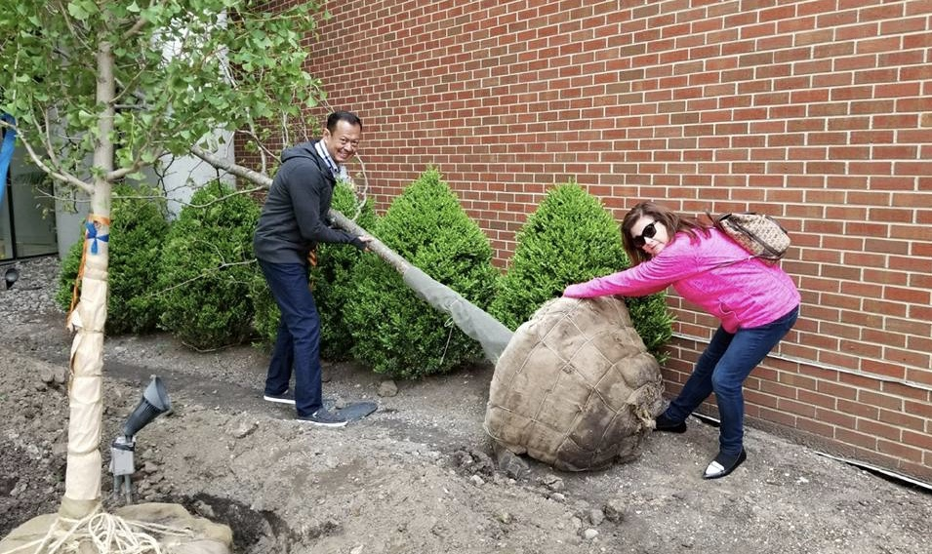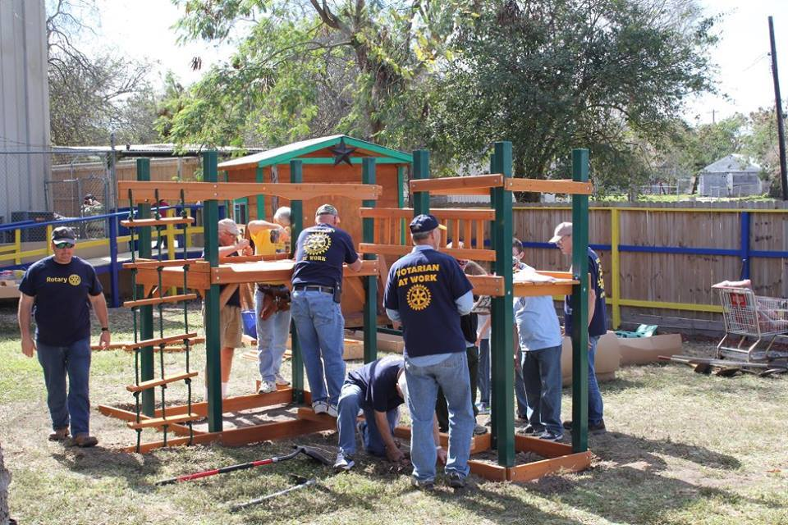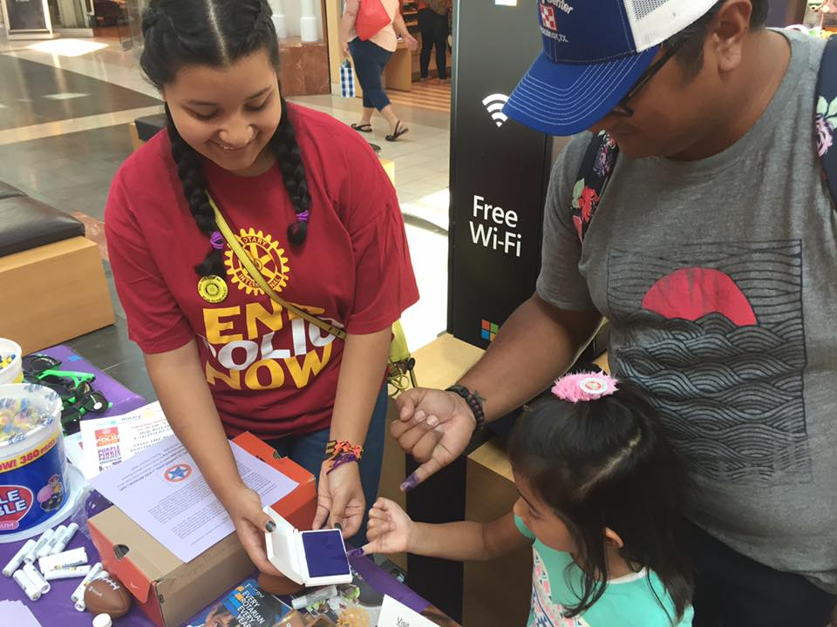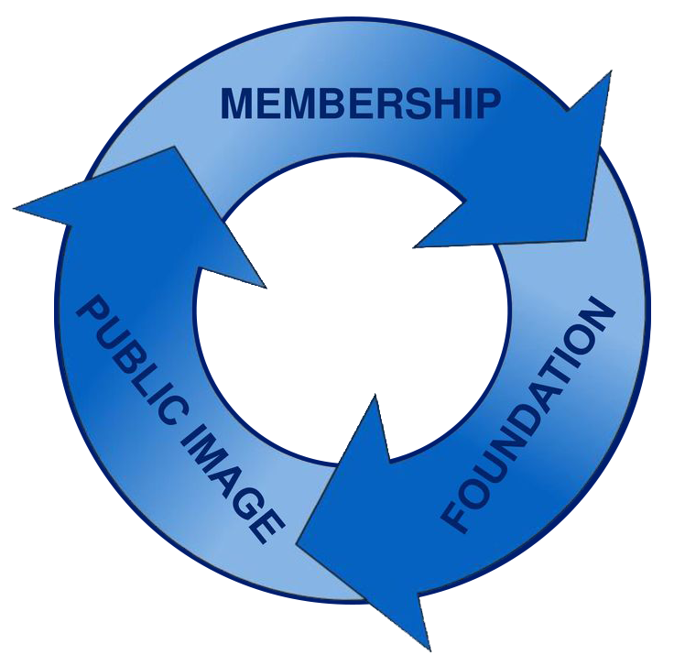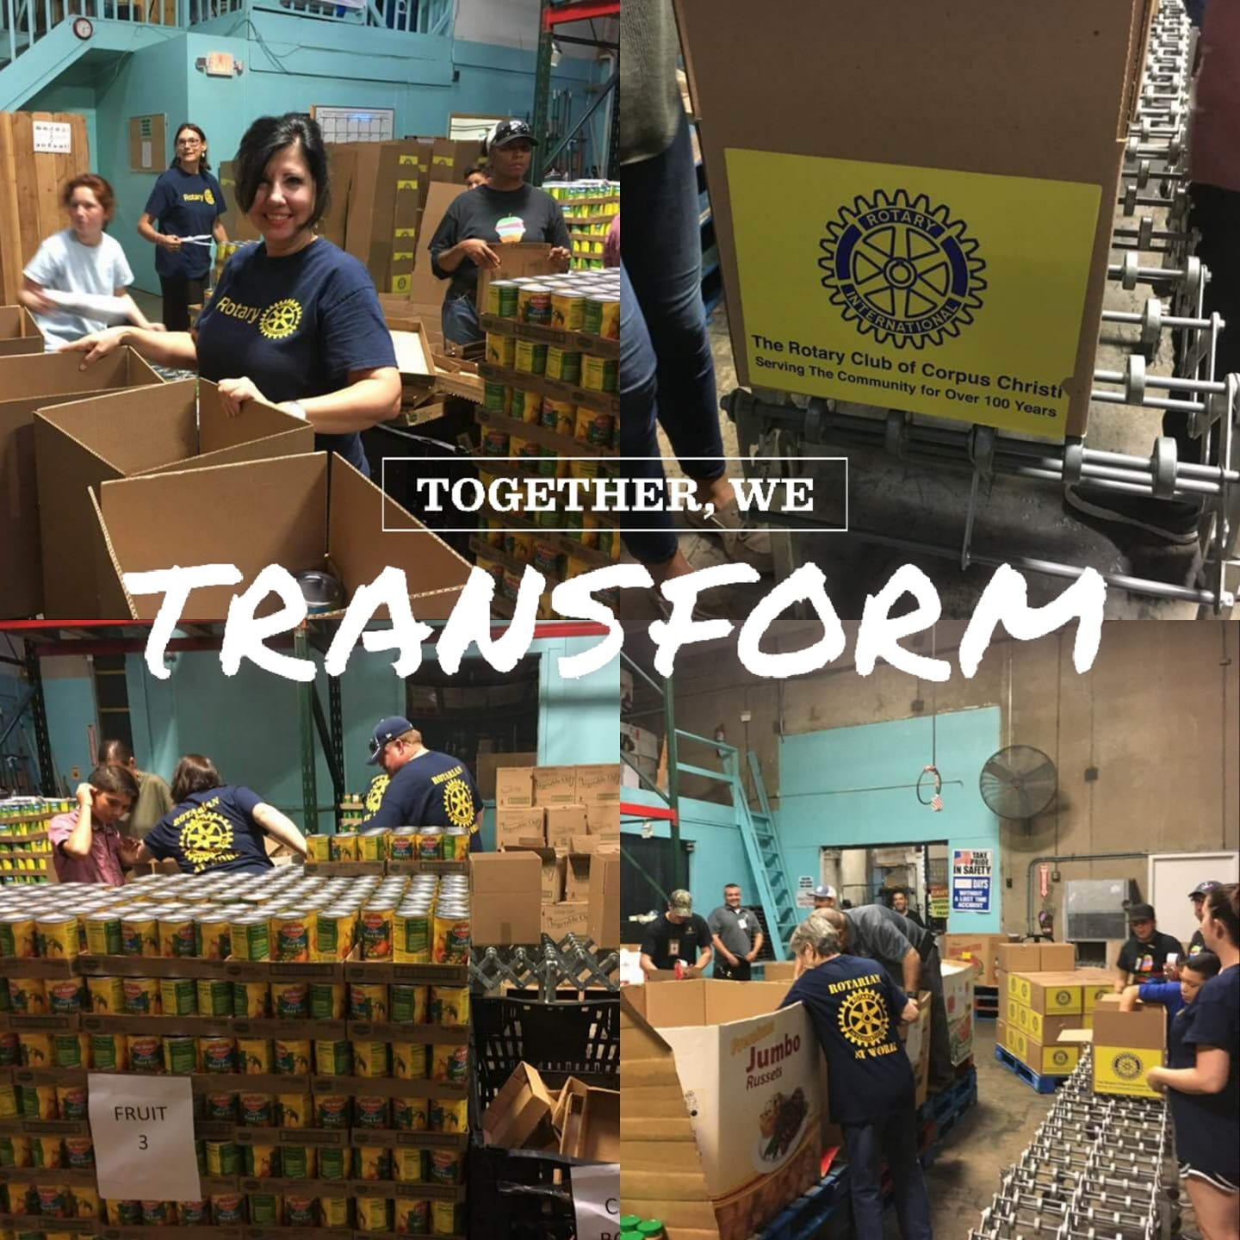

**#peopleofaction**

**#rotaryshowcase**

**#rotaryconnectstheworld**

FB: Rotary International Zone 25b And 29

**http://www.zones25b-29.org**

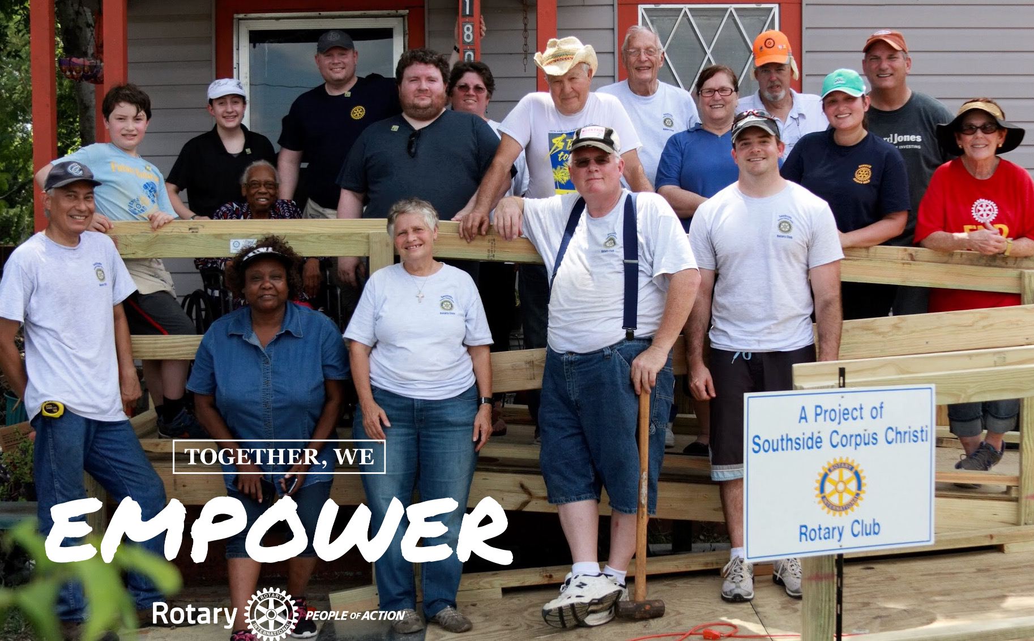ue…

**ROTARY SHOWCASE:** [www.[rotaryclub].org](http://www.[rotaryclub].org)

<https://map.rotary.org/en/project/pages/project_showcase.aspx/>

SOCIAL MEDIA

Rotarians are improving lives in communities around the world every day through thousands of service projects.

Do your members know what you do and why you do it?

Rotary Showcase Week – share your projects and good work that your Rotary club is doing locally and globally. Share your projects with your members, community and your

Facebook friends.

Tell your Rotary Club’s Story

during Rotary Showcase

Week (and beyond).

### Making a difference

# [your club name] Rotary showcase week

