2025-26
Document D
Creating a Custom Logo for your District or Club’s One Summit

- Log in to your My Rotary account at https://www.rotary.org/en:
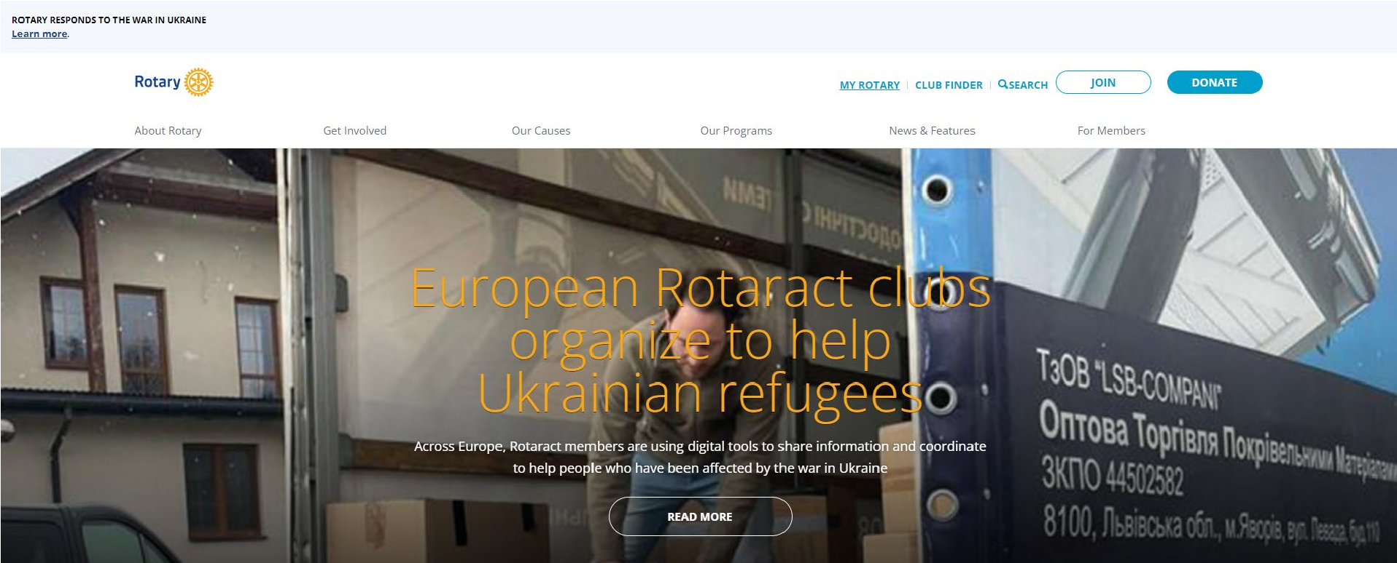

- Navigate to Rotary’s Brand Center:
  - Under Manage in the navigation Bar, choose Brand Center:
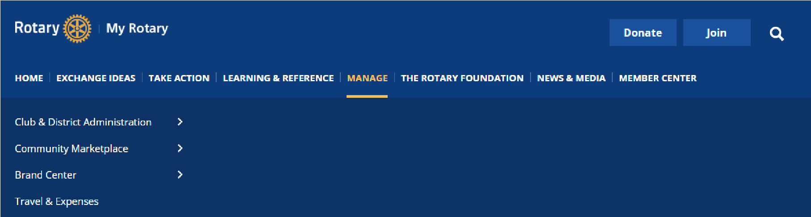

  - Or scroll down the page and select Brand Center from the Online Tools list:
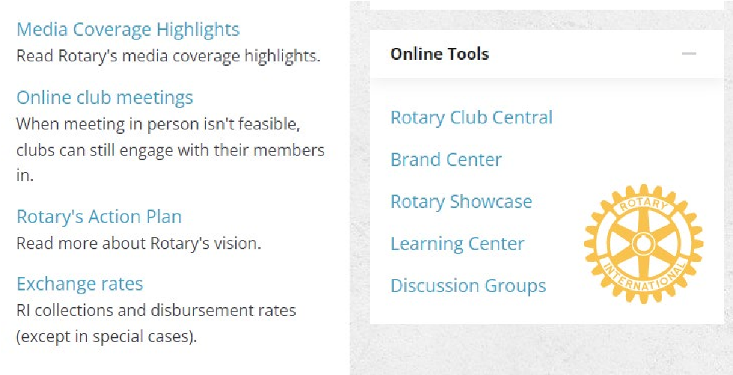

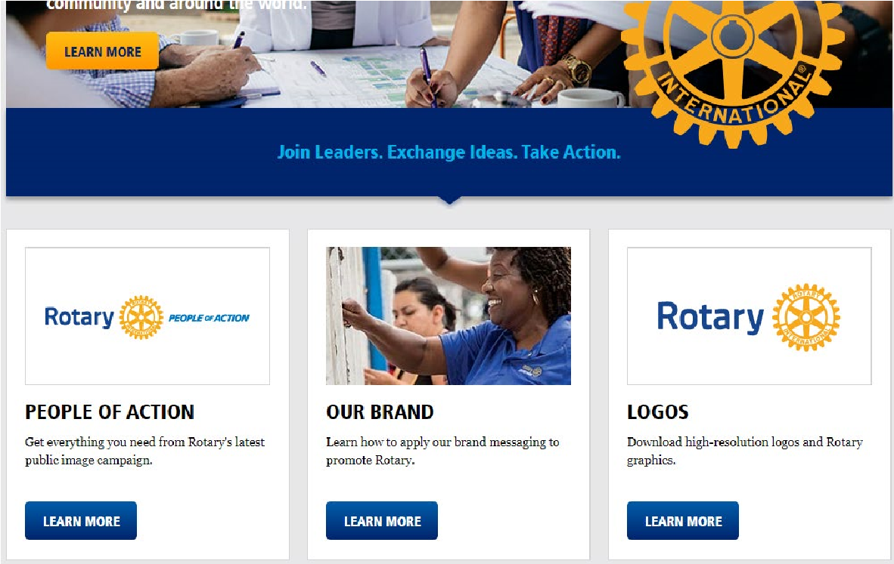
3.

Click on the
Learn More

button in the
Logos
section:

4.

Click on
View
under
Logo Templates
:

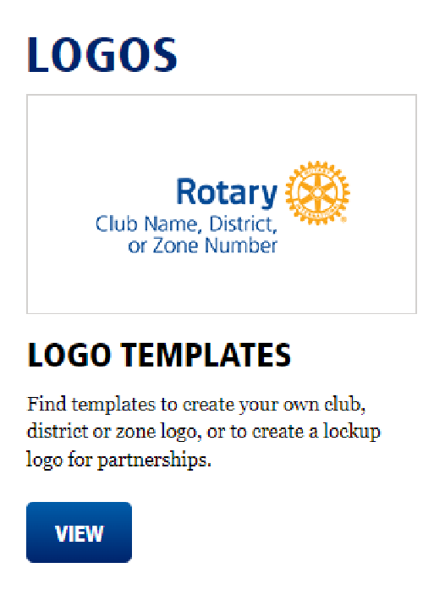

- Scroll down and choose Rotary Logo Lockup Template:
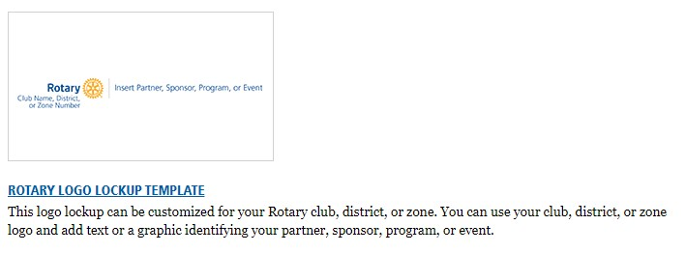

- Under Choose logo arrangement, update the Text below* field to read your District number or Club name:
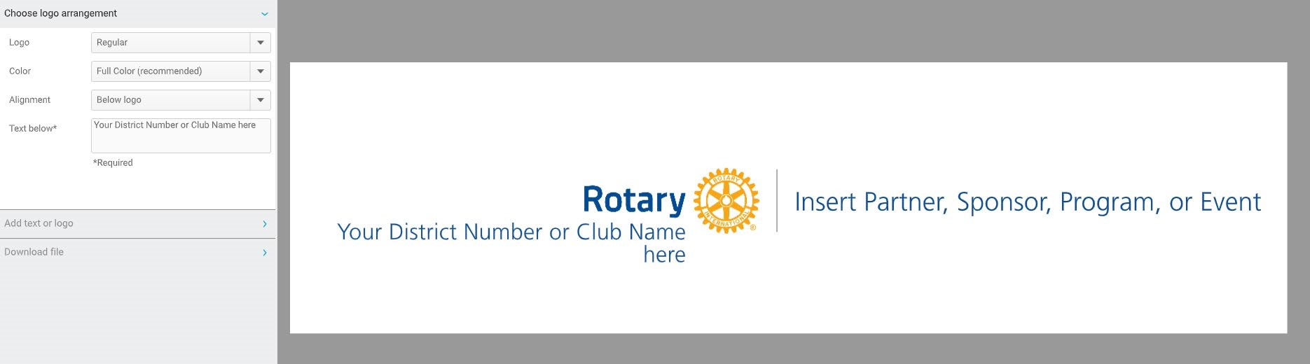

- Expand Add text or logo and update the Text field to read One Summit: Membership, Public Image & The Rotary Foundation Working Together (Change Font size to 12 and Font weight to Bold):
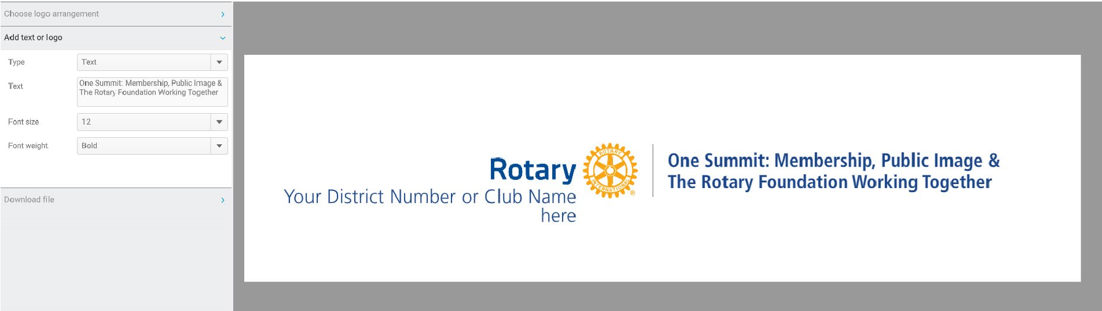

- Download the file; choose PDF for print materials, JPG for digital use, or PNG for digital with a transparent background use:
