Rotary Club Action Plan Summit (RCAPS)
Document 4
Scenarios and Questions
Each participant in each breakout group gets a copy of this page and of the scenario assigned to that breakout group.
Action Plan Synergy
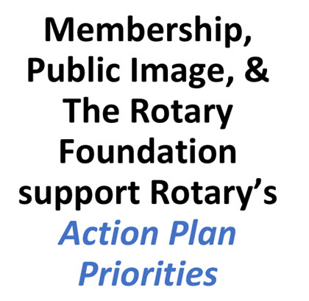

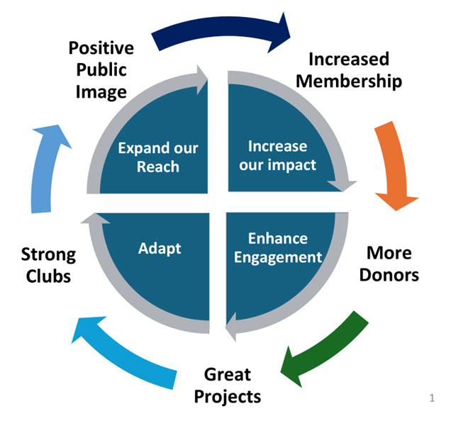
Scenario 1: Struggling Rotary Club Needs Help

Please refer to the Action Plan Synergy Graphic that has been provided to you, as you and those in your breakout group consider this scenario.

For purposes of this scenario, you are a member of a declining Rotary Club that is struggling to add and retain members. At one time, your club had thirty-five members, but over the past 5 years, the club has experienced a net loss of nine members. Even though this club has its own Foundation, donations have dropped to the point where the club can no longer provide grants. Members do not donate to the Rotary Foundation. Attendance at meetings is poor and no one is in line to be president. There is no membership or public image chairperson or committee and there has been no use of social media and no press releases. Service project participation is poor, and the club has no goals.

The newly elected President has asked you and the others in your breakout group as members of the club to create an action plan to turn things around.

Questions for discussion:
- Where would you start?
- What will you include in the action plan?
- How could Membership, Public Image, and The Rotary Foundation work together in your plan?
- You learn that some members of your club do not want to give up and really want to grow and make the club strong again. What resources would you call upon at the club or district level to help?
- Now that your group has produced an extensive list of things to do to help your club, there are far too many goals and actions to focus on immediately. What are the top 3 or 4 things you would focus on in your action plan to give your club a boost and turn things around?

Scenario 2 - Basic Education and Literacy

Please refer to the Action Plan Synergy Graphic that has been provided to you, as you and those in your breakout group consider this scenario.

Your group intends to present a proposal to your Club’s Board of Directors for a Basic Education and literacy project to be financed in part by a Rotary Foundation District Grant and with some additional club support.
The project will be a local community project at an elementary school targeting the third-grade student population. There are 35 students in the third grade.
A community assessment has been done within the last year and revealed the following:
- 37% of the 3rd grade students are below the poverty level.
- 25% are in single adult families, with the parents working multiple jobs.
- Teachers report that many of the students are not reading at grade level.
- Teachers report that all the 37% have no leisure reading books at home or a dictionary.
- Scholastic Books has a discount program for purchasing leisure books or dictionaries.
Questions for Scenario Discussion
- Why propose this project?
- What would you propose your club do, and how would you gain support of your club?
- How could this project help grow your club membership?
- How could this project increase your club’s impact?
- How could this project expand the reach of your club?
- How could this project enhance member engagement in your club?
- How might this project involve your club’s ability to adapt?
- What will be required to accomplish this project?
- Funding and funding sources?
- How will you achieve optimal club member participation?
- What about other partners?
- How will you gain community support and involvement?
- How could Membership, Public Image, and The Rotary Foundation work together to achieve success for this project?
- How could having this project help your club become stronger?
- In general, what would you include in your Club Action Plan for this project?

Scenario 3 - Protecting the Environment

Please refer to the Action Plan Synergy Graphic that has been provided to you, as you and those in your breakout group consider this scenario.

Your club has been successful in attracting new members to join because of a highly engaged Environmental Committee staffed by some young and passionate Rotarians who are focused on protecting and improving the environment. The environmental projects supported by your club include a monthly roadside clean up and removal of invasive species from one of the Conservancies in your community. These projects are highly visible, and new members have joined because of this work. Recently the Environmental Committee has expressed an interest in taking on a larger project that might require more volunteers and additional financial resources to successfully complete. They believe even more members will join if they see the work your club is doing to support the community.
Questions for Scenario Discussion
- Why propose this project?
- What would you propose your club do, and how would you gain support of your club?
- How could this project help grow your club membership?
- How could this project increase your club’s impact?
- How could this project expand the reach of your club?
- How could this project enhance member engagement in your club?
- How might this project involve your club’s ability to adapt?
- What will be required to accomplish this project?
- Funding and funding sources?
- How will you achieve optimal club member participation?
- What about other partners?
- How will you gain community support and involvement?
- How could Membership, Public Image, and The Rotary Foundation work together to achieve success for this project?
- How could having this project help your club become stronger?
- In general, what would you include in your Club Action Plan for this project?

Scenario 4 - Community Economic Development

Please refer to the Action Plan Synergy Graphic that has been provided to you, as you and those in your breakout group consider this scenario.

Your club is in an urban area and recently completed a community needs assessment to determine where to devote volunteer and economic resources to projects that would have the most direct positive impact on the citizens. The assessment revealed a significantly higher unemployment rate in a 12-block area that has existed for many years. The income per household and high school graduation rate was less than 50% of the surrounding areas and attendance at the local community college where plumbing, heating, welding, and electric trades are taught is very low. Crime rates continued to increase, and the recidivism rates are high.
Questions for Scenario Discussion
- Why propose this project?
- What would you propose your club do, and how would you gain support of your club?
- How could this project help grow your club membership?
- How could this project increase your club’s impact?
- How could this project expand the reach of your club?
- How could this project enhance member engagement in your club?
- How might this project involve your club’s ability to adapt?
- What will be required to accomplish this project?
- Funding and funding sources?
- How will you achieve optimal club member participation?
- What about other partners?
- How will you gain community support and involvement?
- How could Membership, Public Image, and The Rotary Foundation work together to achieve success for this project?
- How could having this project help your club become stronger?
- In general, what would you include in your Club Action Plan for this project?

