Rotary Club Action Plan Summit (RCAPS)
Document I
PowerPoint Notes

Download the Summit PowerPoint slide set (Doc H). Save that file to your computer and then edit it to make the changes indicated below.

Slide #  in original  slide set | Action
All | Download the Summit PowerPoint, Doc H, following these instructions. This method will ensure that the video on slide 2 which contains an extremely large file is downloaded.  Instructions to download the Summit PowerPoint, Doc H.  1. Click on the PowerPoint link:  2. Click on Download at the right side of the screen:  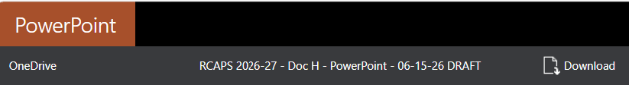  3 Click on Download again at the upper left side of this screen:  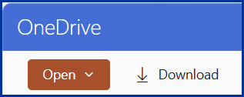  4. Click on the file folder in the browser’s Downloads list:  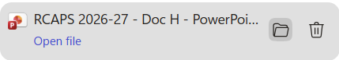  5. That will open the downloads folder. Copy the file to the folder where you are placing the RCAPS files for your Summit.
1 | Welcome Segment.  Insert your district number and/or names of clubs. (See info for  Have this slide displayed as attendees enter the plenary room and during the first five minutes of Welcome segment as you welcome them, introduce yourself and your DG and other district leaders who will be involved in the Summit.
2 | Welcome Segment. Video – featuring RI President Babalola and RI President-elect Lunsford. Due to its size this video will not be downloaded unless the PowerPoint deck is downloaded as explained above for “All” slides.
3-6 | Welcome Segment. Use these slides during the Welcome segment of the Summit. They explain the Rotary Club Action Plan Summit approach, Action Plans, and Rotary’s Vision Statement.
7-9 | Welcome Segment. Use these slides as your District’s Action Plan Champion (or another district leader) explains and encourages having Three-Year Action Plans at the club level.
10 | Welcome Segment. Graphic illustration of how Membership, Public Image, and The Rotary Foundation work together to support your Club’s Action Plans.
11 | Welcome Segment. Short video about Creating Lasting Change. . You may have to hover on the bottom of the slide to see the start ► and begin the video.
12 | Welcome Segment. Display for the transition to the next Segment.
12-26 | Bringing the Rotary Action Plan and Membership Growth to Life in Your Club – Notes for the presentation are provided in the PowerPoint as notes on the bottom of slides.
27 | Break.
28 | Scenario Discussion.
29 | Wrap-Up. Show as this Segment begins and during Scenario Discussion Sharing.
30 | Wrap-Up. Moving from ideas to Action. Show until it is time to show District Information or to thank participants and close the Summit.
31 | District Information. Optional but recommended – Insert contact information for district leaders and/or how to find that information on the District website page.
32 & 33 | Use these slides to thank participants and close the Summit

